ELP 551
Titus Pollard, DPLA Fellow
My Understanding of the Four Disciplines of Execution
April 13, 2018

The name Covey is synonymous for books and materials that speak to the human nature in order to move self, other individuals, and groups of people. The tenets of The 7 Habits of Highly Effective People is ingrained into my current educational path, and is a distinct part of my understanding of how school leadership can be successful.
As I examine educational leadership in general and school-building level transformation in particular, one of the texts used for reference and study in this semester course came from author Franklin Covey ®, The Four Disciplines of Execution. This book is the basis for this reflective paper.
I would say that the central difference between 7 Habits and Disciplines (or 4DX ) is that the first book is a concentration on what one can usually see in successful leaders, while the second book maps out steps a leader or group should take to successfully move an agenda or idea. I believe that if the philosophies of both these books are incorporated into a vision, success (in school transformation) can be achieved.
I will take a bit of creative license in demonstrating my understanding of 4DX. I will attempt to correlate the four disciplines in the book to a current visionary desire that the principal of my current school, Lakeview Secondary, wishes to convey. The disciplines explained in the book are: 1. Focus on the Wildly Important, 2. Act on the Lead Measures, 3. Keep a Compelling Scoreboard and, 4. Create a Cadence of Accountability.
Focus on the Wildly Important
The principal of my current school, Dr. Theresa McGowan, created what she called a “100 – Day Plan” for Lakeview which she presented to the school’s selection team at time of her interview for the position. She became principal on or around December, 2017, in her first job as a building leader but not her first in a supervisory position. Approximately 30 days later, I was selected as the middle-grades assistant principal (AP). Along with the high school AP, Dr. Lori Bruce-Jawo, we have begun to formulate into a solid administrative team with a sincere desire to move Lakeview into greatness. We mistakenly, however, became engrossed in our daily routines without deciding what our primary focus needed to be. What would be our WIG or wildly important goal(s)?
Sometime in March, I heard Dr. McGowan say that she hated out-of-school suspensions. She believes that underlying reasons exists within children that school officials, namely administration, often don’t pay attention to when they see misbehavior. “I want to see our school attend to the social-emotional needs of students,” she would say while she rubs her chin. She has stated this desire numerous times, to stakeholders of varying positions, in many settings and paraphrased several different ways. For me, that was the WIG. Her desire for a radical change in how a school disciplines a student has to be repeated, broadcast, even marketed. This same desire was in her 100-Day Plan – once we took the time to revisit it. This was where our focus needed to be. According to 4DX, execution of a goal begins with focus. This desire is wildly important to her, and it has become wildly important to me. It allows Lakeview to narrow its focus and apply energy to a central goal. In reference to this desired goal, this is Lakeview’s demonstration of Discipline #1.

Act on the Lead Measures
Discipline #2 describes how to determine lag versus lead measures, and how creating a path of steps toward a goal and outlining your plan keeps success in sight. When I relate this to Lakeview School’s WIG, this is how I view the vision pictorially:
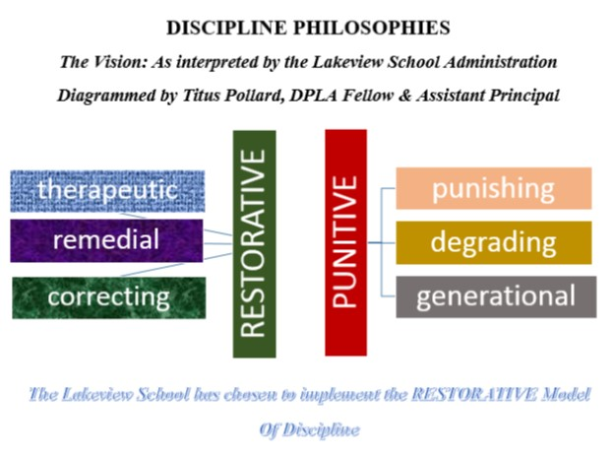
I designed this diagram and showed it to Dr. McGowan, who agreed that it properly depicted the conflicting forms of student discipline. Once the admin team had a visual for restorative discipline, we could begin to collaborate on how to incorporate lead measures to attain an ultimate goal: to have a school culture that leans toward restorative, therapeutic styles of student discipline. Collaboratively developed and tracked over time and utilizing leverage, the lead measures can be predictive and influence-able.
Keep a Compelling Scoreboard
“How are we doing,” is something that I often hear Principal McGowan ask. It is important to know exactly how a team is doing in the goal-achievement game. Discipline #3 addresses the activity of keeping a scorecard, some qualitative or quantitative method for gathering data so that you know how close or far you are from reaching the ultimate goal. For Lakeview Secondary, this is why re-examining School Improvement Plans, Teacher Working Surveys, EVAAS, summative tests and the rest of the wide arrays of data points are relatively important. These types of data can be compelling scorecards. In the Durham School District, the Educator Handbook (EH) application is an aid in determining how close Lakeview is to its WIG - moving toward a therapeutic style of student discipline. EH keeps a compelling scorecard on the number of times students are referred to administrative discipline (punitive) versus the number of times a student is referred for student or parental conferences (therapeutic). The EH is a scorecard displaying Lakeview’s actual performance as 4DX would describe. “How are we doing?”
Create a Cadence of Accountability
Who will be responsible for what? More importantly, what will the attitude be as we do what is needed?
This cadence of accountability is probably the most difficult 4DX, because it is heavily engrossed in human interaction, and shifts in climate and culture. You first have to convince people that a shift is better for the organization than, “the way we been doing things.” Liken this to Lakeview and the desired shift from punitive to therapeutic student discipline. My short experience with the staff has shown me that the staff has an ingrown culture of student mistreatment, lackadaisical attitudes toward students, and a status quo in work responsibility. Apparently, this style is decades old. So, to have a new principal come in with a new vision is not something that a veteran staff readily takes to. But the leader is relentless. “You have to hold people accountable,” she’ll say, and then point to me. “This is your hall,” referring to the middle school hallway. So through renewed commitments to weekly staff meetings, SIT meetings, grade level meetings and sincere connections to students as the true customer in education, Lakeview will meet its WIG with a steady drum beat – a cadence – of accountability.

